Lecture 2.2.5
Congruence Relations

Course outcome to be covered:
CO1: Apply and recognized about the Congruence Relations

Congruence Relation
Congruence Is a statement about divisibility If an integer m O divides the difference a-b we say that a is congruent to b modulo m and is written as a b(mod m). Congruence is one of the most important aspects of Mathematics, as Mathematics is a useful and powerful tool of science 00 & Society. It is developed by Gauss - a German mathematician.
Theorem
If a = b (mod m) b = c (mod m) then a = c (mod m)
The relation of congruency in a group G is defined by a≡b(modH) if and only if ab–1∈H is an equivalence relation.
Proof:
(i) Reflexivity:
Let a∈G then a–1=e∈H because H is a subgroup of G.
Hence a≡a(modH) ∀a∈G. The relation is reflexive.
(ii) Symmetry:
a≡b(modH)
⇒ab–1∈H
⇒(ab–1)–1∈H
⇒ba–1∈H
⇒b≡a(modH)
Hence the relation is symmetric.
(iii) Transitivity:
a≡b(modH)andb≡a(modH)
⇒ab–1∈Handba–1∈H
⇒(ab–1)(bc–1)∈H
⇒a(b–1b)c–1∈H
⇒ac–1∈H
⇒a≡c(modH)
Hence the relation is transitive.
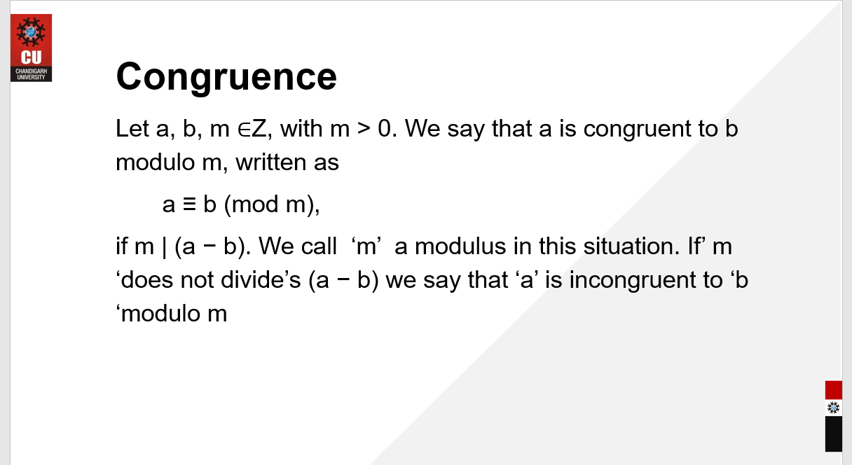
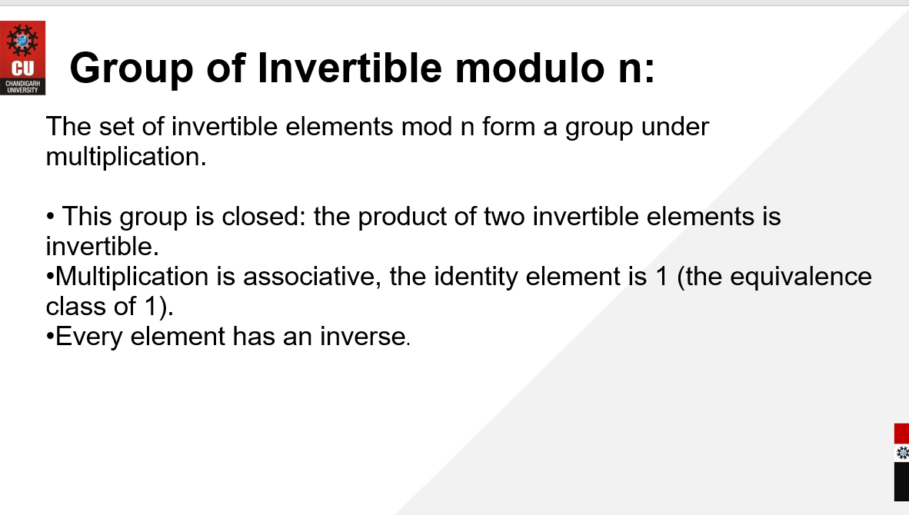
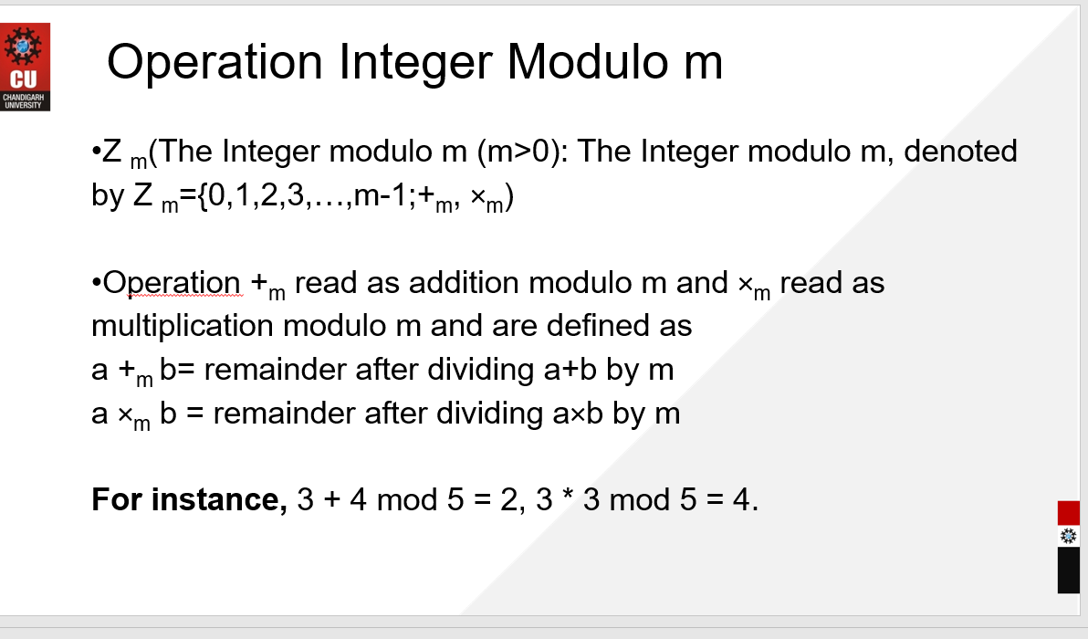

eBook Discrete Mathematics :
https://www.uobabylon.edu.iq/eprints/paper_11_21140_649.pdf

Video link: https://www.youtube.com/watch?v=-SpWfD4WsmM

